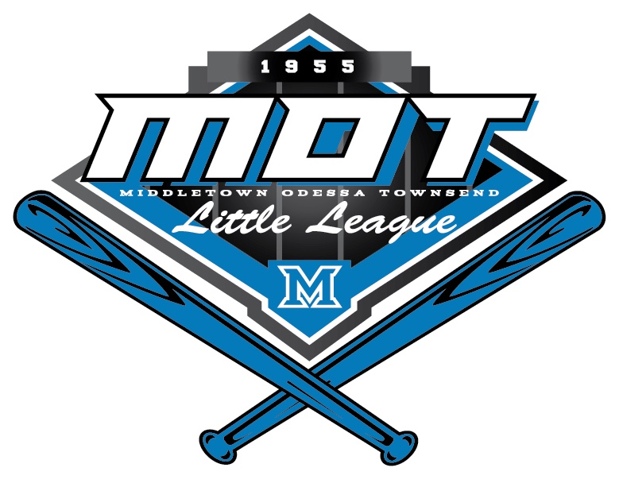

MOT Little League
Safety Plan
2024

Prepared by:
Brian Beard – Safety Officer

Aaron Blythe – President
League I.D. – 208-01-10
http://motll.com

Table of Contents
Introduction and Safety Goals 3
Contact Information 4
Emergency Contact Information 4
MOTLL Board Contact Information 4
Accident Reporting and Insurance Claims 5
Reporting an Accident to MOTLL 5
Little League Accident Notification Form 5
Field Safety, Equipment Inspection, and Inclement Weather Conditions 6
Pregame Inspection and Considerations 6
Equipment Checks 6
First Aid Kits and AEDs 7
Inclement Weather and Lightning 7
Volunteer Application 8
Training 9
Fundamentals Training: 9
First-Aid Training: 9
Additional Training Programs: 9
Preventing Common Baseball Injuries 10
Appendices: 11
A: First Aid Training Coaches Clinic Topics 11
B: Field Layouts 15
C: Safety Audit Checklist 17

Introduction and Safety Goals

Participation in any sport raises the possibility of an injury occurring, and this is certainly true in baseball and softball. The goal of this safety plan is to increase awareness for how managers, coaches, umpires, parents, and participants all play an important role in reducing the risk of serious injuries, and how to respond when one should occur. We are looking forward to an amazing 2024 Little League season. Please contact me should you have any questions or concerns.

Sincerely,
Brian Beard – MOTLL Safety Officer
302-222-7940
Safetyofficer@MOTLittleLeague.com

Safety Plan Goals:

- Foster a safe environment so that our players can learn and enjoy the game of baseball and softball.
- Provide critical information, such as emergency contact numbers, League Board Member names and numbers, location of AEDs, first aid kits, and other important safety equipment.
- Explain the volunteer application process that includes a criminal background check for all volunteers and umpires.
- Teach managers and coaches effective techniques to reduce and avoid injuries and how to handle serious injuries when they occur.
- Communicate equipment requirements as outlined in the Little League Safety Code to ensure that all players are properly equipped.
- Train managers and coaches on how to effectively respond to medical emergencies, administer first aid, and document them appropriately.
- Ensure that all volunteers receive training to help identify, eliminate, and report instances of emotional, physical, or sexual abuse.
- Develop awareness of unsafe weather conditions and when games should be cancelled or postponed due to lightning, extreme heat, or other inclement weather conditions.

Contact Information

Emergency Contact Information

Emergency | Number | Non-Emergency | Number
Police and Fire | 911 | Middletown Police | 302-376-9950
Ambulance | 911 | Middletown Fire Department | 302-378-7799
 |  | Odessa Fire Department | 302-378-7075
 |  | Townsend Fire Department | 302-378-8111
 |  | Delaware State Police – Troop 9 | 302-378-5218
 |  | Town of Middletown | 302-378-2211
 |  | Chesapeake Utilities | 800-427-2883
 |  | Delmarva Electric | 800-898-8042

Area Hospital and Emergency Rooms | Address | Number
ChristianaCare – Middletown ER | 621 Middletown Odessa Rd  Middletown, DE 19709 | 302-203-1300
ChristianaCare - Urgent Care | 749 Middletown Warwick Rd  Middletown, DE 19709 | 302-273-1614
Christiana Hospital | 4755 Ogletown Stanton Rd  Newark, DE 19718 | 302-733-1000
A.I. DuPont Hospital | 1600 Rockland Rd.  Wilmington, DE 19803 | 302-651-4200
Kent General | 640 South State Street  Dover, DE 19901 | 302-674-4700

MOTLL Board Contact Information

Name | Position | Phone Number | Email Address
Aaron Blythe | President | (302) 685-0173 | AaronBlythe@MOTLittleLeague.com
Tom Peters | Vice President &  Volunteer Coord. | (845) 527-3754 | TomPeters@MOTLittleLeague.com
Julie Eide | Player Agent |  | PlayerAgent@MOTLittleLeague.com
Kevin Bailey | VP - Baseball | (302) 593-3771 | Baseball@MOTLittleLeague.com
Matt Brown | VP - Softball | (919) 900-0401 | Softball@MOTLittleLeague.com
Jaclyn Mahle | VP – T-Ball & Instructional BB | (443) 206-3187 | Instructional@MOTLittleLeague.com
Brian Yarborough | Secretary | (302) 383-9875 | BrianYarborough@MOTLittleLeague.com
Kenny Branner | Treasurer | (302) 378-7870 | KBranner@Middletown.Delaware.Gov
George Kilbride | Chief Umpire | (302) 598-1275 | taz0831@aol.com
Linda Lappert | Information Officer | (302) 449-1240 | InformationOfficer@MOTLittleLeague.com
Brian Beard | Safety Officer | (302) 222-7940 | Brian.c.beard@gmail.com

Accident Reporting and Insurance Claims

Reporting an Accident to MOTLL

All significant safety incidents and injuries must be reported to the league safety officer by completing the form linked below. Incidents are to be reported within 24-48 hours from when they occur. In general, this should be an incident that requires some degree of medical attention, or first aid administered. When in doubt, fill out the form.

MOTLL Incident/Injury Tracking Form

Little League Accident Notification Form

Whenever an accident occurs, and there is the possibility of incurring medical expenses, guardians should consider completing the Little League Accident Notification Form. Please note the important procedures and steps outlined below. This is a secondary insurance policy which would cover expenses incurred that are not covered by your primary insurance. There is a $50 deductible per injury.

- This form must be completed by parents (if claimant is under 19 years of age) and a league official and forwarded to Little League Headquarters within 20 days after the accident. A photocopy of this form should be made and kept by the claimant/parent. Initial medical/ dental treatment must be rendered within 30 days of the Little League accident.
- Itemized bills including description of service, date of service, procedure and diagnosis codes for medical services/supplies and/or other documentation related to claim for benefits are to be provided within 90 days after the accident date. In no event shall such proof be furnished later than 12 months from the date the medical expense was incurred.
- When other insurance is present, parents or claimant must forward copies of the Explanation of Benefits or Notice/Letter of Denial for each charge directly to Little League Headquarters, even if the charges do not exceed the deductible of the primary insurance program.
- Policy provides benefits for eligible medical expenses incurred within 52 weeks of the accident, subject to Excess Coverage and Exclusion provisions of the plan.
- Limited deferred medical/dental benefits may be available for necessary treatment incurred after 52 weeks. Refer to insurance brochure provided to the league president or contact Little League Headquarters within the year of injury.
- Accident Claim Form must be fully completed - including Social Security Number (SSN) - for processing.
- Additional instructions for submitting and Accident Insurance Claim

Field Safety, Equipment Inspection, and Inclement Weather Conditions

Little League has several safety provisions included in the rulebook and many are cited in the bullet points below. Follow this link for the complete Little League Safety Code. All managers, coaches, umpires, and players are expected to enforce and follow all of the requirements outlined in the safety code.

Pregame Inspection and Considerations

Fields are routinely inspected to ensure that they are safe for play. However, conditions can change quickly, and managers, coaches, and umpires are required to inspect the field before each game for the following:

- No games or practice should be held when weather or field conditions are not good, particularly when lighting is inadequate.
- Play area should be inspected frequently for holes, damage, glass, and other foreign objects.
- Dugouts and bat racks should be positioned behind screens.
- Only players, managers, coaches, and umpires are permitted on the playing field during play and practice sessions.
- Responsibility for keeping bats and loose equipment off the field of play should be that of a regular player assigned for this purpose.
- Regulations prohibit on-deck batters. This means no player should handle a bat, even while in an enclosure, until it is his/her time at bat. This applies only to Little League (Majors), Minor League, and Tee Ball.

Equipment Checks

- Equipment should be inspected regularly. Make sure it fits properly.
- Bats must be compliant with Little League Bat Rules: Bat Rules - Little League
- Pitching machines, if used, must be in good working order (including extension cords, outlets, etc.) and must be operated only by adult managers and coaches.
- Batters must wear protective NOCSAE helmets during practice, as well as during games.
- Catchers must wear catcher’s helmet (with face mask and throat guard), chest protector, and shin guards. Male catchers must wear a protective supporter and cup at all times.
- Parents of players who wear glasses should be encouraged to provide “Safety Glasses.”
- Players must not wear watches, rings, pins, jewelry, hard cosmetic, or hard decorative items.
- Catchers must wear catcher’s helmet, face mask, and throat guard in warming up pitchers. This applies between innings and in bullpen practice. Skull caps are not permitted.
- Batting/catcher’s helmets should not be painted unless approved by the manufacturer.

First Aid Kits and AEDs

Multiple first aid kits and ice packs will be distributed to each field location. The league safety officer will ensure that each field has enough first aid kits at the beginning of each season. These should be checked by managers and coaches before each game, and the league safety officer should be notified if any stock needs to be replenished.

Managers are given basic instructions for AED use during the annual safety training. AED locations are clearly marked with signage at each location and are depicted on the field layout maps (Appendix B).

Inclement Weather and Lightning

- Any umpire, manager, or coach is empowered to suspend a game due to the observation of lightning or thunder near the ballfield. If one game is suspended, all games at the location must be suspended immediately.
- Games shall be suspended when lightning is visibly seen or detected within 10 miles of a field.
- In general, thunder is heard when a lightning strike occurs within 10 miles and games should be suspended when thunder is heard.
- When a game is suspended due to lightning, all players and spectators are required to return to their car and take shelter for at least 30 minutes from the last observed lightning strike.
- It is the discretion of the umpire to suspend the game for other inclement weather conditions such as heavy rain or winds that make playing conditions unsafe.

Volunteer Application

All volunteers (managers, coaches, scorekeepers, etc.) and umpires are required to complete a volunteer application, a background check, and complete USA Baseball’s Abuse Awareness Training.

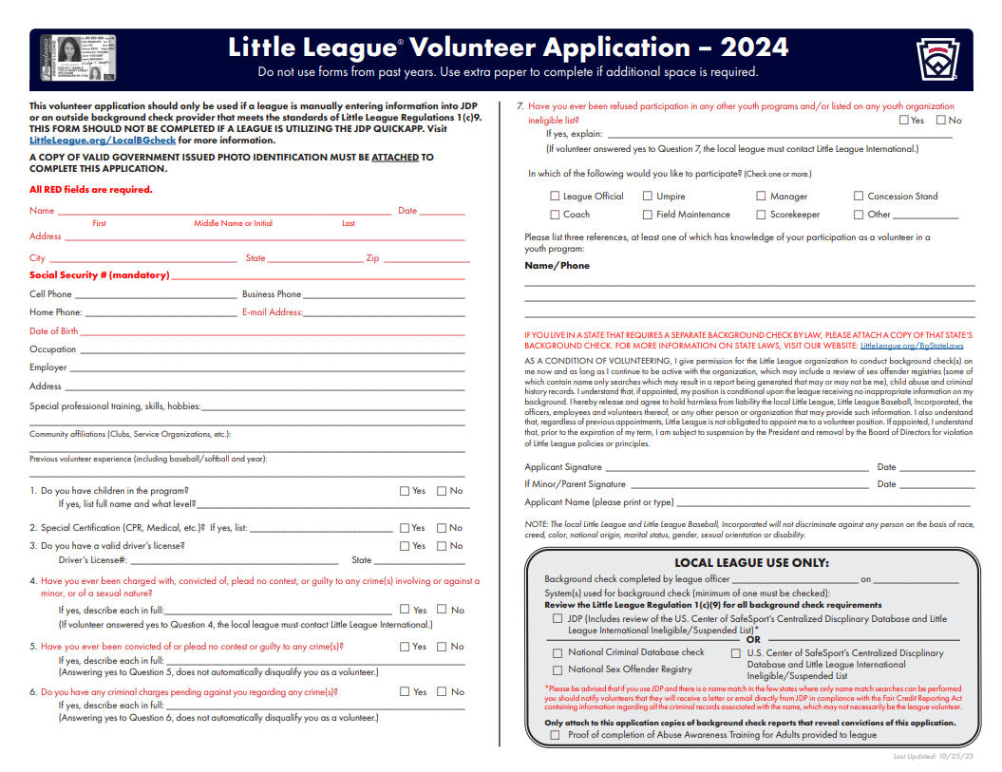

Training

Learning, growth, and development is not only important for our ballplayers, but coaches and volunteers as well. MOTLL organizes and participates in several training initiatives to ensure that our managers are teaching the game of baseball and softball in a safe and effective manner.

Fundamentals Training:

All MOTLL teams are required to send one coach or manager to a training session that covers division specific rules and fundamentals training that is tailored to the players age and skill level. These sessions are held before the beginning of the spring and fall seasons.

First-Aid Training:

MOTLL requires at least one manager/coach from each team to attend a first aid training session that will be conducted by the League Safety Officer. The training will be conducted annually, and a coach must have received training within the last three years.

The most recently held training was conducted on March 29th, 2023, and was led by Shane Tuffy. The next session will be conducted in March of 2024.

**See Appendix A: First Aid Training Coaches Clinic Topics for an overview of the safety topics and materials that are covered as part of this training.

Additional Training Programs:

Diamond Leader: a program that is developed by Little League and focuses on the mental, social, and emotional well-being of our athletes and how a coach can have a positive impact on all three aspects. This training is required for all-star managers and coaches and is encouraged for all our volunteers.

USA Baseball Athlete Safety Education (BASE) Abuse Awareness Training: this program covers several topics related to emotional, physical, and sexual misconduct, mandatory reporting requirements, and policies pertaining to coach and trainer interactions with athletes. This is mandatory training for all MOTLL volunteers and umpires.

Preventing Common Baseball Injuries

Here are some tips to help prevent common baseball injuries:

- Warm up and cool down: Make sure to properly warm up before playing and cool down after playing to help prevent muscle strains and other injuries.
- Use proper technique: Using the correct technique when throwing, catching, and hitting can help prevent injuries. Make sure to receive proper instruction from a coach or trainer.
- Wear protective gear: Wearing the appropriate protective gear, such as helmets, mouthguards, and protective cups, can help prevent injuries.
- Stay hydrated: Make sure to drink plenty of fluids before, during, and after playing to help prevent dehydration and heat-related illnesses.
- Avoid overuse: Overuse injuries are common in baseball, especially in pitchers. Make sure to rest and avoid overusing the same muscles to help prevent these types of injuries.
- Conditioning: Participate in a conditioning program that focuses on building strength, flexibility, and endurance to help prevent injuries.
- Rest and recover: Make sure to get enough rest and allow your body to recover between games and practices to help prevent injuries.

By following these tips, you can help prevent common baseball injuries and stay healthy while playing the game.

Concession Stands and Food Safety

MOTLL has discontinued the use of our concession stand facilities and is partnering with fully licensed and inspected food truck operators. The following rules and procedures remain in effect should the league decide to resume operation of our concession stands.

MOTLL Concession Stand Rules and Regulations

- Locate Fire Extinguisher to be used in the event of an emergency.
- Do not work in overcrowded conditions.
- All workers must be at least 16 years old unless under direct adult supervision. No children under 12 are allowed in the concession stand.
- Always show courtesy to customers.
- Be aware that French Fryer, Heat Lamps, Grill, and Water are or may be EXTREMELY HOT!
- Closed toe shoes are required. No bare feet or open-toed shoes at any time
- Remember to wash your hands prior to handling food, or between other activities.
- The last shift is responsible for clean-up and preparation for the next concession duty. This includes:
  - Washing down grills, counter tops, and utensils
  - Be sure the heat lamps, French fryer, and other electrical appliances are turned off.
  - Restock drink coolers, fill condiment containers, fill napkin holders, and be sure soda containers are not empty.

Appendices:

A: First Aid Training Coaches Clinic Topics

Most Common Sports Injuries – Sprains, Strains, and Contusions (Bruises) = PRICES
- P – PROTECTION: The use of protective gear and safety awareness can prevent many common injuries from occurring

- R – REST: The first 24 – 48 hours after an injury is considered the crucial period.

- I – ICE: The first 48 hours after the injury, you must ice and elevate 20 minutes at a time every 3 to 4 hours. Do not ice for more than 20 minutes because you do not want to damage the tissues.

- C – COMPRESSION: Use compression when elevating

- E – ELEVATE: For example, an ankle injury needs to be elevated higher than the heart as often as possible. This is especially important at night.

- S – SUPPORT: Crutches and other assistive devices may help injured player move around and heal without adding damaged to the injured area

What are Sprains, Strains, and Contusions?

- Sprains – occurs at our joints. Injury to ligament. Overstretching to tear of the ligament. Ligaments hold our joints together like rubber bands. (Degrees – 1st Degree – Mild, 2nd Degree – Moderate, 3rd Degree – Severe)
- Strains- injury to our muscle (overstretching or tearing of the muscle)
- Contusions – injury to soft tissue. Resulting in bruising.

Other Common Injuries:
- Fractures
- Dislocations (LOOK, LISTEN, FEEL)
- Injuries to small joints
- Facial Injuries
- Injuries to teeth
- Eye injuries
- Insect bites & stings
- Heat Illness
- Head Injuries & Concussions (doctor’s release required for return)
- Spinal Injuries
- Seizures
- Asthma Attacks
- Diabetic Incidents
- Choking
- Allergic Reactions (Bee Stings, Food allergies, etc…)
- Other Health Diagnoses

Heat Index Policy:
- The league reserves the right to close fields and cancel games & practices when the heat index approaches dangerous level (at, around or above 100 degrees)

Tips to Prevent Injury:
- Proper maintenance of playing / practice sites & inspection of fields
- Pay attention to playing & weather conditions
- Ensure players know basics & benefits of good nutrition
- Proper athletic conditioning (stretching, warm-up, agility drills, etc…)
- Avoid over use (pay attention to activities outside Little League)

Some DO’s and Don’ts
DO…..
Reassure and aid children who are injured, frightened, or
lost. Provide, or assist in obtaining, medical attention for those .
who require it. Know your limitations! Assist those who require
medical attention – and when administering aid, remember to:

- LOOK for signs of injury (Blood, Black-and-blue deformity of joint etc...)
- LISTEN to the injured describe what happened and what hurts if conscious. Before questioning, you may have to calm and soothe an excited child.
- FEEL gently and carefully the injured area for signs of swelling or grating of broken bone
- Be familiar with the information on your player’s Medical Release Forms & have them with you at all games and practices.
- Arrange to have a cellular phone available at your games and practices
- Keep emergency contact phone numbers with your Medical Release Forms.

Remain calm and do not exceed your limitations. Don’t…
- Provide any food or beverages other than water
- Hesitate in giving aid when needed
- Be afraid to ask for help, if you’re not sure of the proper procedures(i.e. CPR, AED, etc….)
- Transport injured individuals except in extreme emergencies
- Leave an unattended child at a practice or game

CPR & AED Basics
If you are untrained, or trained but not too confident in your abilities:
If you've never been trained in CPR, or have been but are unsure about giving rescue breaths, then use hands-only CPR. Hands-only CPR involves uninterrupted chest compressions of 100 to 120 per minute until an EMT arrives. You do not include rescue breathing with this technique.

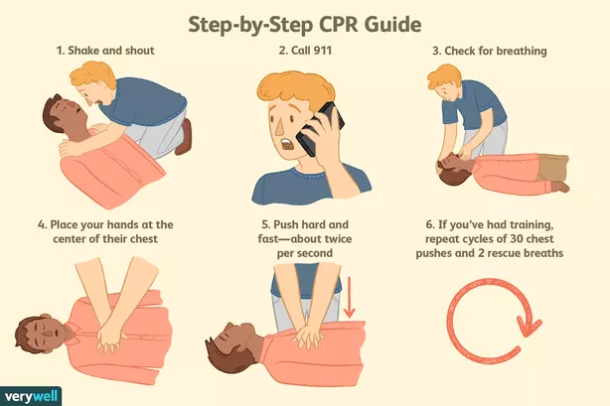

Using the AED
- Check unresponsiveness.
- Call 9-1-1 or the local emergency number (if applicable) and retrieve the AED.
- Open the airway and check for breathing. ...
- Check for a pulse. ...
- Attach the AED electrode pads.
- Analyze the heart rhythm. ...
- Press the "shock" button, if advised.

AED’s are located at press box storage rooms (Senior Baseball and Front Softball Fields) at silver lake and storage room next to concessions at Duke.

Heimlich Maneuver – When Person is Conscious
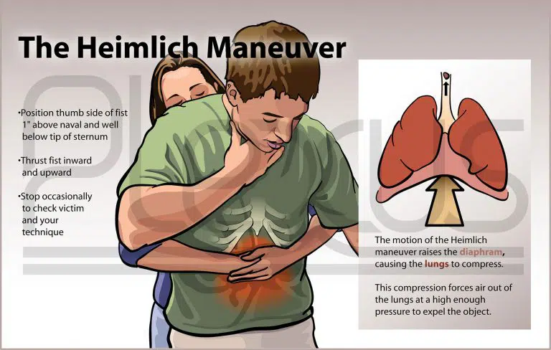
- Make a fist and place it just above the navel, thumb side in.
- Grab the fist with your other hand and push it inward and upward at the same time. Perform five of these abdominal thrusts.
- Repeat until the object is expelled and breathing or coughing begins.

B: Field Layouts

Silver Lake Park: 200 E. Cochran Street, Middletown, DE 19709
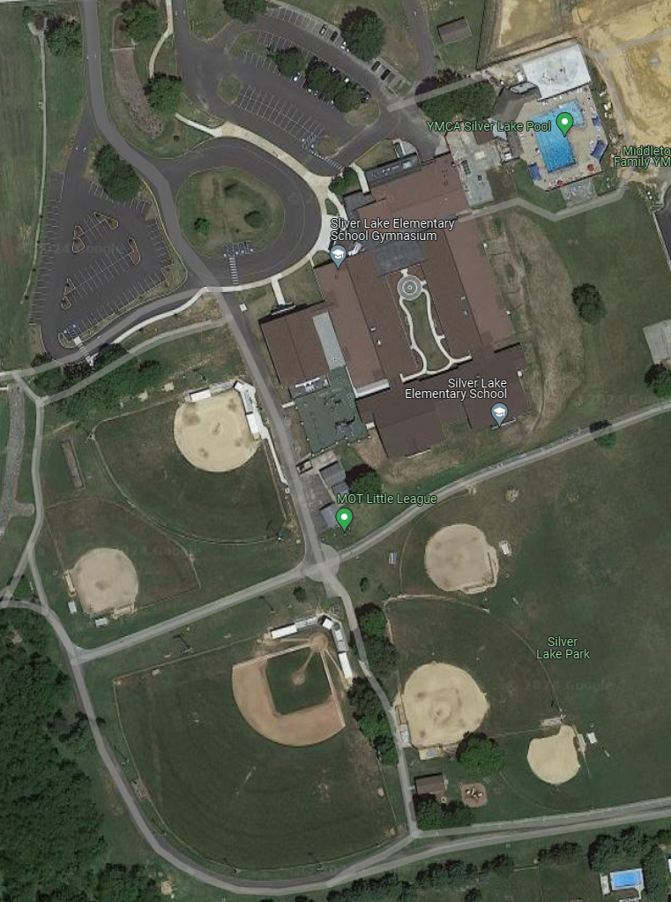

Field 3:
Minor Baseball
Field 4:
Minor Softball
Field 2:
Major/Sr Softball
Field 5:
Baseball
Field 6:
Tee Ball
Field 1:
Jr/Sr Baseball
Parking Lot
Parking Lot
Duke Field: 450 Cleaver Farm Road, Middletown, DE 19709
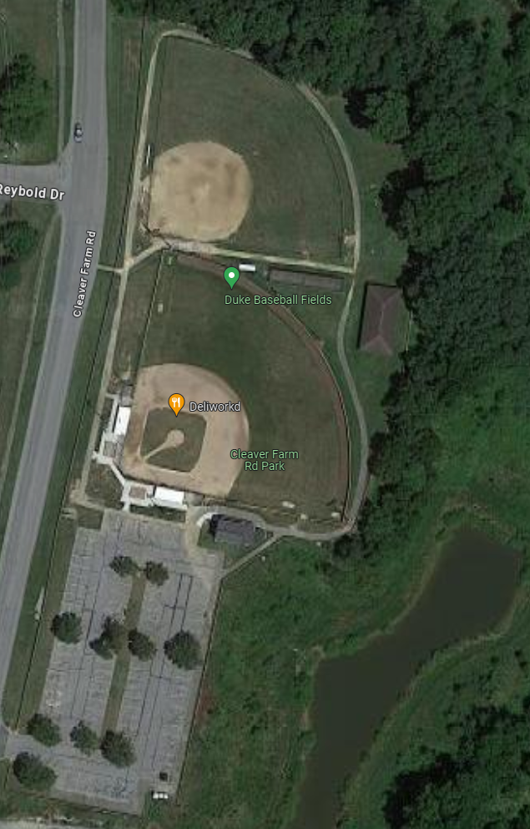
Parking Lot
Duke 1
Duke 2

C: Safety Audit Checklist

